
Surname N, ‘Title in the language of the contribution' (2027) 1 EJPLT.
DOI:

ISSN 2704-8012
© The author(s) 2027, published by Suor Orsola Benincasa Università Editrice.
This contribution is licensed under a Creative Common Attribution 4.0 International Licence CC-BY-NC-ND, all the details on the license are available at: https://creativecommons.org/licenses/by-nc-nd/4.0/


Title in the language of the contribution

English title (if the contribution is in English, please provide here Italian title)

Name Surname (ORCID) 
Academic qualification of the author(s)
University

Abstract

The abstract can be up to 1.000 characters long, excluding spaces.
The abstract must be in tow languages, i.e. the language of the contribution and English.
If the contribution is in English, the abstract should be in English and Italian.
Also in this cases the abstract can be a maximum of 1.000 characters (excluding spaces) in order to fit in this box.

The title of the article can be up to 130 characters excluding spaces in order to be sure that both title and abstract can fit this box. If the contribution is in a language other than English, the title must be in two languages, i.e. the language of the contribution and English.
If the contribution is in English, the title should be in English and Italian.
Keywords: keyword; keyword; keyword.

Summary: 1. Paragraph Title. – 2. Paragraph Title. – 3. Paragraph Title. – 4. Paragraph Title ……………………………………………………………….

- Paragraph Title/Titolo paragrafo.
LoremIpsumDolor LoremIpsumDolor LoremIpsumDolor LoremIpsumDolor LoremIpsumDolor LoremIpsumDolor LoremIpsumDolor LoremIpsumDolor LoremIpsumDolor LoremIpsumDolor LoremIpsumDolor LoremIpsumDolor LoremIpsumDolor LoremIpsumDolor LoremIpsumDolor LoremIpsumDolor LoremIpsumDolor LoremIpsumDolor LoremIpsumDolor LoremIpsumDolor.

- Paragraph Title
LoremIpsumDolor LoremIpsumDolor LoremIpsumDolor LoremIpsumDolor LoremIpsumDolor LoremIpsumDolor LoremIpsumDolor LoremIpsumDolor LoremIpsumDolor LoremIpsumDolor LoremIpsumDolor LoremIpsumDolor LoremIpsumDolor LoremIpsumDolor LoremIpsumDolor LoremIpsumDolor LoremIpsumDolor LoremIpsumDolor LoremIpsumDolor LoremIpsumDolor

- Titolo paragrafo
LoremIpsumDolor LoremIpsumDolor LoremIpsumDolor LoremIpsumDolor LoremIpsumDolor LoremIpsumDolor LoremIpsumDolor LoremIpsumDolor LoremIpsumDolor LoremIpsumDolor LoremIpsumDolor LoremIpsumDolor LoremIpsumDolor LoremIpsumDolor LoremIpsumDolor LoremIpsumDolor LoremIpsumDolor LoremIpsumDolor LoremIpsumDolor LoremIpsumDolor

Instructions (to be deleted at the end of the drafting of the contribution)

Number of characters:
Maximum 30.000 characters, footnotes excluded. The indications of the number of characters are indicative and NOT mandatory.
Language:
English, Spanish, Italian or French
Formatting:
Please note that the graphic formatting of the file is partially 'locked', as the formatting choices have been 'embedded' in the file itself.
However, these are the Ccharacters required:
Ubuntu, point 12 for the text, point 10 for the footnotes and for images’ description colour black.
Layout: margins of the document 3 cm; first line indent 0.5; single line spacing.

To create a new paragraph, simply type the paragraph number (e.g. 2, 3, 4...) followed immediately by a dot '.' and then press the Space key. This will automatically set the chosen formatting for the paragraph title in terms of font, size and text colour.

E.g. see below

1. Test for Paragraph Title

As soon as Authors start a new line under the paragraph title, then the default formatting for the body of the text will automatically be applied.
The same for footnotes: simply insert a new footnote and it will have the graphical text setting adopted by the Journal.

Mandatory cover image:
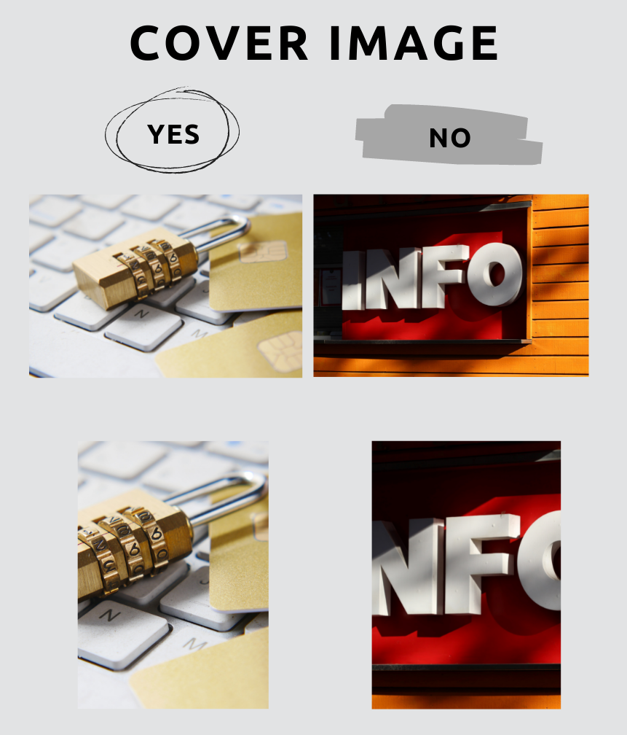
Authors are asked to send a cover image related to the contribution topic, that the Publisher will include on the first page of the contribution. The image should be selected from one of the websites that provide open access and free of charge images (e.g. Unsplash: https://unsplash.com/s/photos/new-technology-law).
The cover image must be sent in JPEG or JPG format, with a separate file from the one containing the text of the contribution.
We kindly ask to select images that can be cut from the Editorial Team to be inserted in the first page of the contribution, in the precise space provided therein.
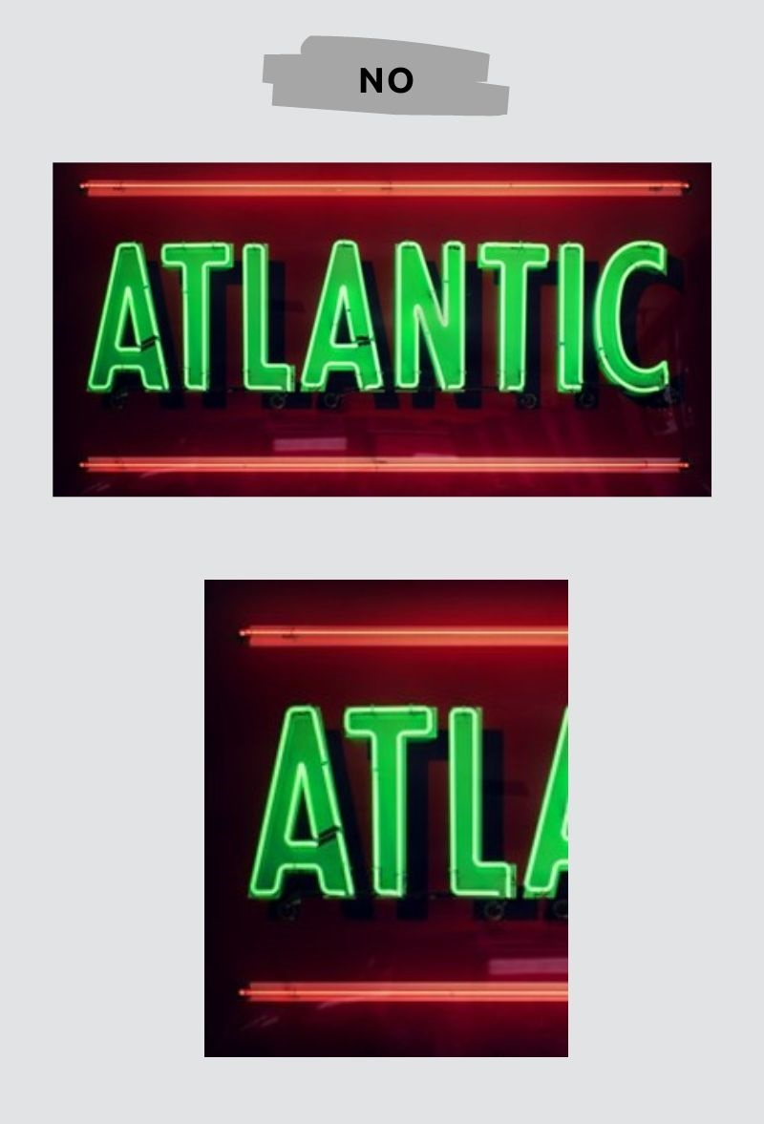
In any case, there are some image formats that are always to be considered inadequate, such as the horizontal 16:9 and 21:9 formats. In fact, if we try to cut it we will always get a bad result as you can see below.
This is an example of a 16:9 image, now it should be clear why you must avoid them.
Another problem is the image resolution. When we cut an image, the new image’s resolution won’t change and adapt to the cut.
So, we kindly ask you to do not give us a horizontal image 16:9 and 21:9 formats.

ORCID ID.
Authors are invited to register on ORCID (https://orcid.org/), a free access platform that aims to connect research and researcher: The Authors should indicate the URL to their ORCID ID on the first page of their contributions after their name and academic/professional qualification.

Citation.
Contribution citation at the top left
Authors are invited to insert the citation of their contribution on the first page at the top left using the OSCOLA citation criteria available at the following link:
https://universitypress.unisob.na.it/ojs/materiali/English_Standard_for_the_Citation_en.pdf
Standards of citation of the footnotes
Author should use of the following standards of citation, depending on whether the contribution is in English or in Italian.
» English Standard for the Citation
» Italian Standard for the Citation
If the contribution is in English, indicate footnotes with a superscript number which should appear after the relevant punctuation in the text (if any).
Example.¹
If the contribution is in Italian, indicate footnotes with a superscript number which should appear before the relevant punctuation in the text (if any).
Example.¹

Images in the text.
If relevant, images are very welcome.
To make it clearer which images we propose to use, we indicate below the main usable types (preferably in colour):
- Explanatory photographs of the topic dealt with [we require to use the images according to copyrights regulation and to specify the source from which the images were extracted];
- Diagrams on the trends of relevant data for the contributions;
- Graphs of different types representing data;
- Representative schemes of concepts covered in the contribution.

Footnote text standard
TestTestTest

